Notes from NASSP Student Leadership Webchat: Virtual Service
5/5/2020
General Considerations
- Remember the meaning and purpose of service: to render care and concern for your community. That includes family, friends, peers, colleagues, and ultimately starts with yourself.
- Virtual service requires more brain power, and less blood/sweat/tears-type of service and volunteer work. Since we can’t be physically doing things that we used to, the emphasis with virtual service is about connectivity, critical thinking, and community-mindedness.
- Categories of Service:
  - Advocacy: The primary function is spreading awareness, campaigning, and/or lobbying about an issue. This can include working on a political campaign or raising awareness for an issue such as drunk driving, a disease, environmental cause, etc.
  - Fundraising/Collection Drives: The primary function is fundraising or collecting goods for an organization or cause. Examples include clothing, food or blood drives, Relay for Life or similar fundraising efforts, and any project for which fundraising or collection of goods was the primary purpose and service activity.
  - Volunteer Service or Action: This section is reserved for those activities in which you performed a service by primarily serving with a talent, skill, or labor-based activity. Examples include (but are not limited to) serving meals at a food kitchen or event, tutoring/teaching, playing music, or building or beautification projects (e.g., Habitat for Humanity).
  - Service-Learning or Service Education Program: Service that is conducted as part of a service-learning or education program. Examples include service-learning programs, mission trips, service-learning courses (e.g., training to be a volunteer First Responder or CPR training.), and tuition-based service experiences. Actual service hours or reflection should focus only on time spent on service activities (e.g., building, teaching/instruction, and other activities that benefited the community you were serving.)
Some acts of service are a combination of things and parts of a whole, larger project. Like organizing an event to raise money for a local non-profit requires activities that are Volunteer Actions (READ: blood/sweat/tears) and also fundraising. The primary goal of the entire event may be fundraising, but a specific individual/participant may do primarily a particular type of activity or task.
- Service hours, making them really count.
  - Don’t just make students do stuff for “approval”
  - But give credit! Making accommodations, self-reporting (honor code!), alternative verification and approval of hours, uploading of photos instead of reports, logs, using a shared doc and having student leaders help with granting approvals (if allowed)
  - You may find some alternatives better than the ways you were doing them to begin with!

- Difference between and activity and a project:
  - A service activity is just something you do, typically individually and standalone. Can also be an ongoing engagement.
  - A service project requires planning, and typically has multiple steps and engages teamwork. A project also has a definitive beginning and end.
  - Example: If you provide free child card or tutoring to someone on a regular basis. That’s an activity, could be service. Organizing a Parents Night In (one day Parents Night Out), where students organize a virtual game night for young kids to play and engage them while the parents can enjoy a quieter (than usual) evening in

High School
- Idea for video appreciation from Rachel Kastelein (Golden HS). Planning document for inspiration here
- Care not COVID
- Phone-a-thons/Well-Being Checks
- Don’t Rush Challenge
- Blood Drives (can help online organizing appointments in conjunction with a center) American Red Cross
- Adopt a middle or elementary school, or connect with other high schools and share resources, fulfill community needs in a nearby community
- Provide tutoring or extracurricular fun/enhancements to young students who are also stuck at home
- Get your student leaders, especially officers involved. Give the student the chance to come up with ideas and drive the projects!

Middle Level
- How to build a Neighborhood Pod
- Encourage teens/student leaders to take care of their mental health UNICEF USA resource
- Coordinate a community garden project, great for urban and suburban areas. If your chapter/council does this as project, coordinate safe social-distancing measures to work on the garden at different times
- Teacher Appreciation Week
- Organize a book drive to distribute books (safely) on doorsteps of students/families that need reading resources (even e-books are hard to come by right now!)
- Spread awareness about positive ways to fight COVID-19

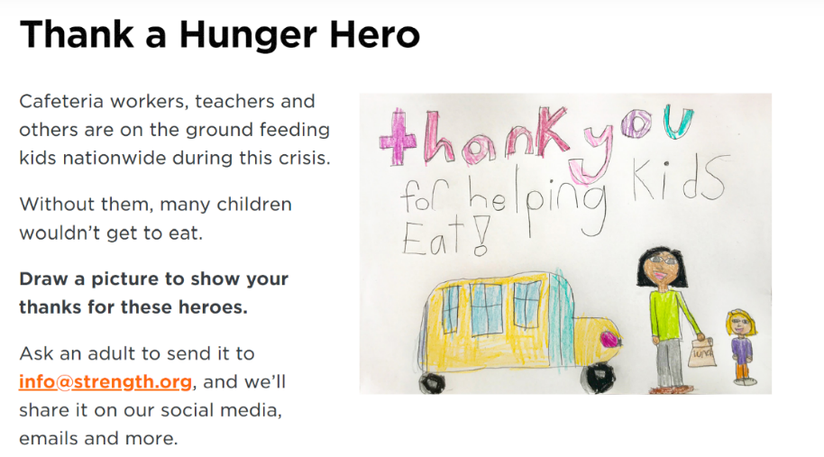
Elementary
- Thank a Hunger Hero, Support No Kid Hungry www.nokidhungry.org
- Kindness Rocks campaign
- Thank You card-writing for community helpers (first responders, doctors, firefighters, nurses, EMTs, etc.)

YSA Resources and Links
- www.YSA.org/covid
- https://leadasap.ysa.org/dogoodfromhome/
- https://leadasap.ysa.org/gysd/#ideas
- www.YSA.org/vote

